TEACHER USE ONLY!

Name:

SONG OF CHOICE
4 – Excellent 3 – Good 2 – Fair 1 – Still Needs Work

- Vocal Tone: Clarity of sound, Volume, Projection

4 3 2 1

- Intonation

4 3 2 1

Notes:

THE STAR SPANGLED BANNER
4 – Excellent 3 – Good 2 – Fair 1 – Still Needs Work

- Vocal Tone: Clarity of sound, Volume, Projection

4 3 2 1

- Intonation

4 3 2 1

Notes:

SINGING IN HARMONY
(Student was accurately able to sing harmony while I sang melody)

4 3 2 1

Notes:
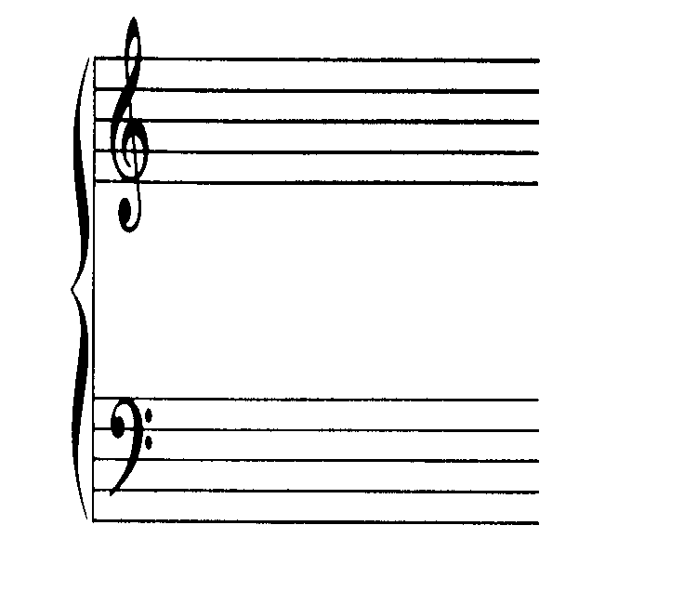

SCORE:
CB:

